**Part 1**

**Exercise 1:**

1-2-3-4-5-6

**Exercise 2:**

1-2

3-

4-

5-6 pgrep httpd -l

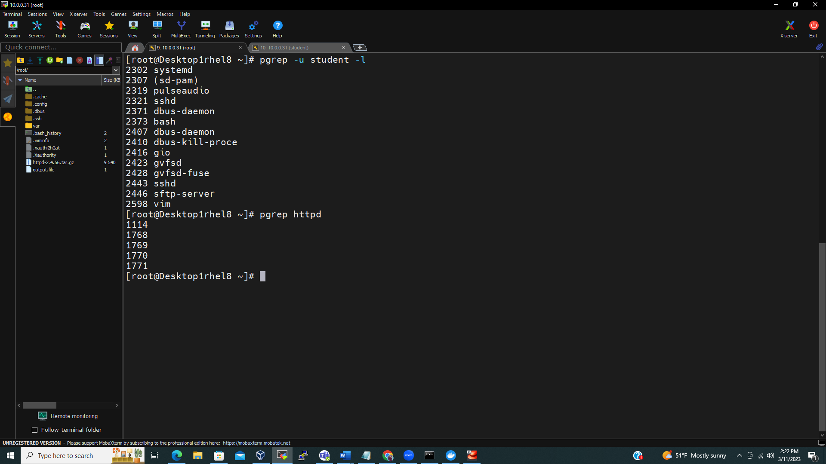

7-

route terminal

student terminal

Route terminal

student terminal

**Part 2:**

**1-**

**2-**

3-4-5

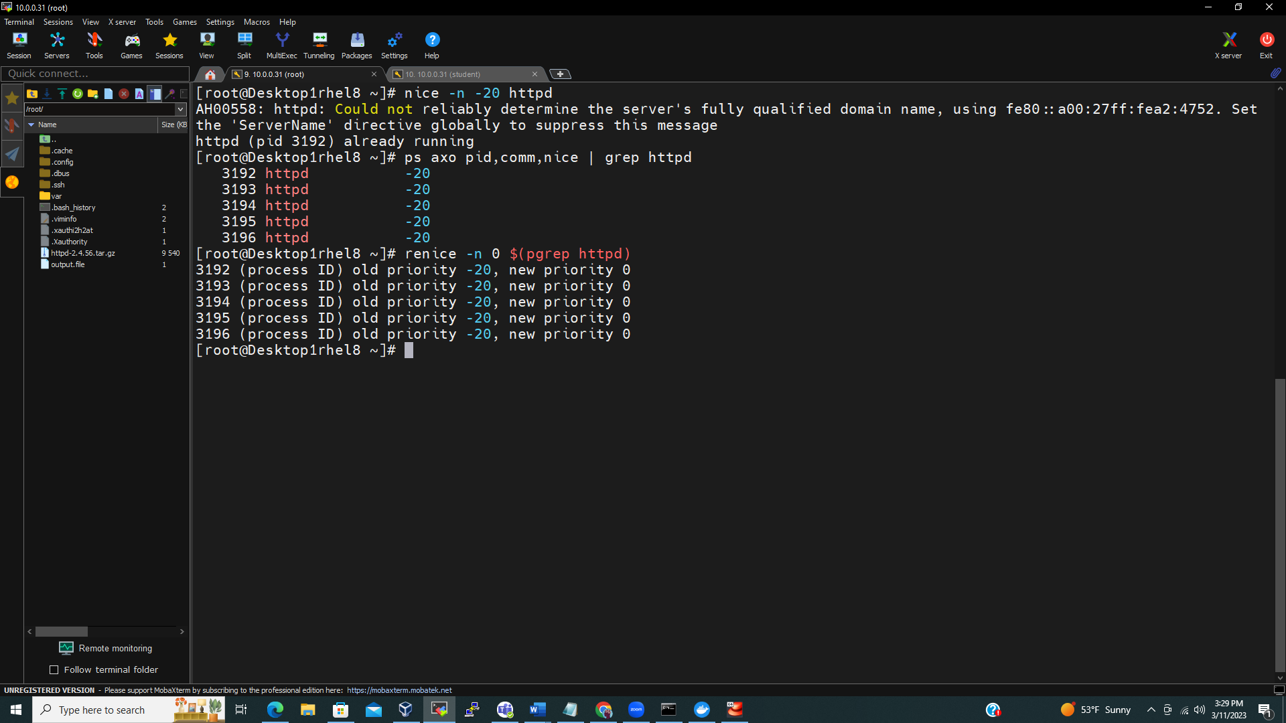

Part 3:

1-2

3-

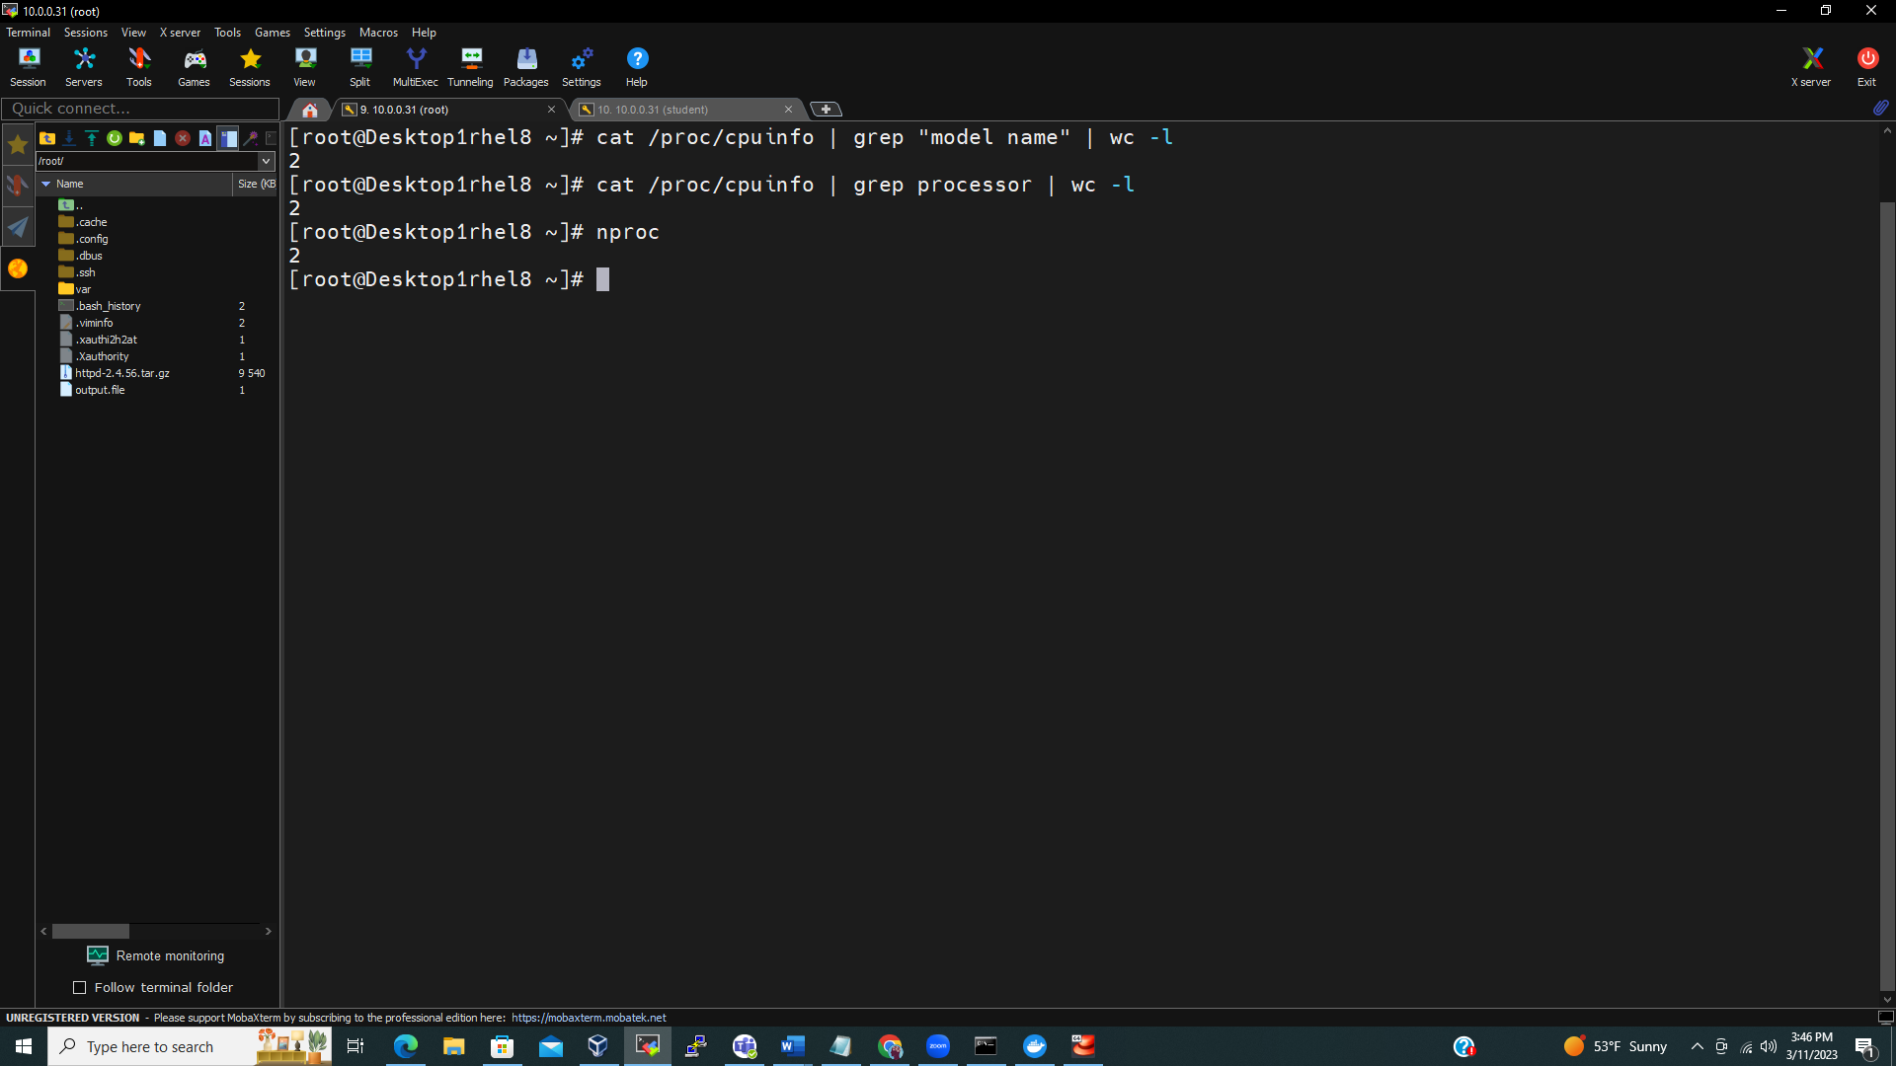

Current load average: 0.00, 0.00, 0.00

0.00/2 * 100 = 0.0% (the system was not using during the last minute)

0.00/2 * 100 = 0.0% (the system was not using during the last 5 minutes)

0.00/2 * 100 = 0.0% (the system was not using during the last 15 minutes)

Part 4:

2- down and up arrow key

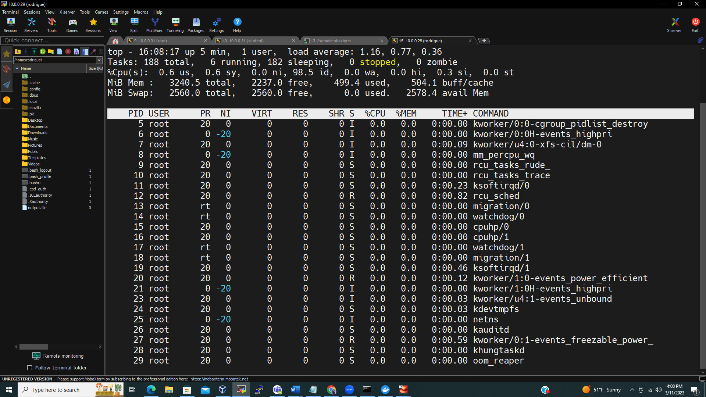

3-

top -o +%MEM or press SHIFT+m or uppercase M

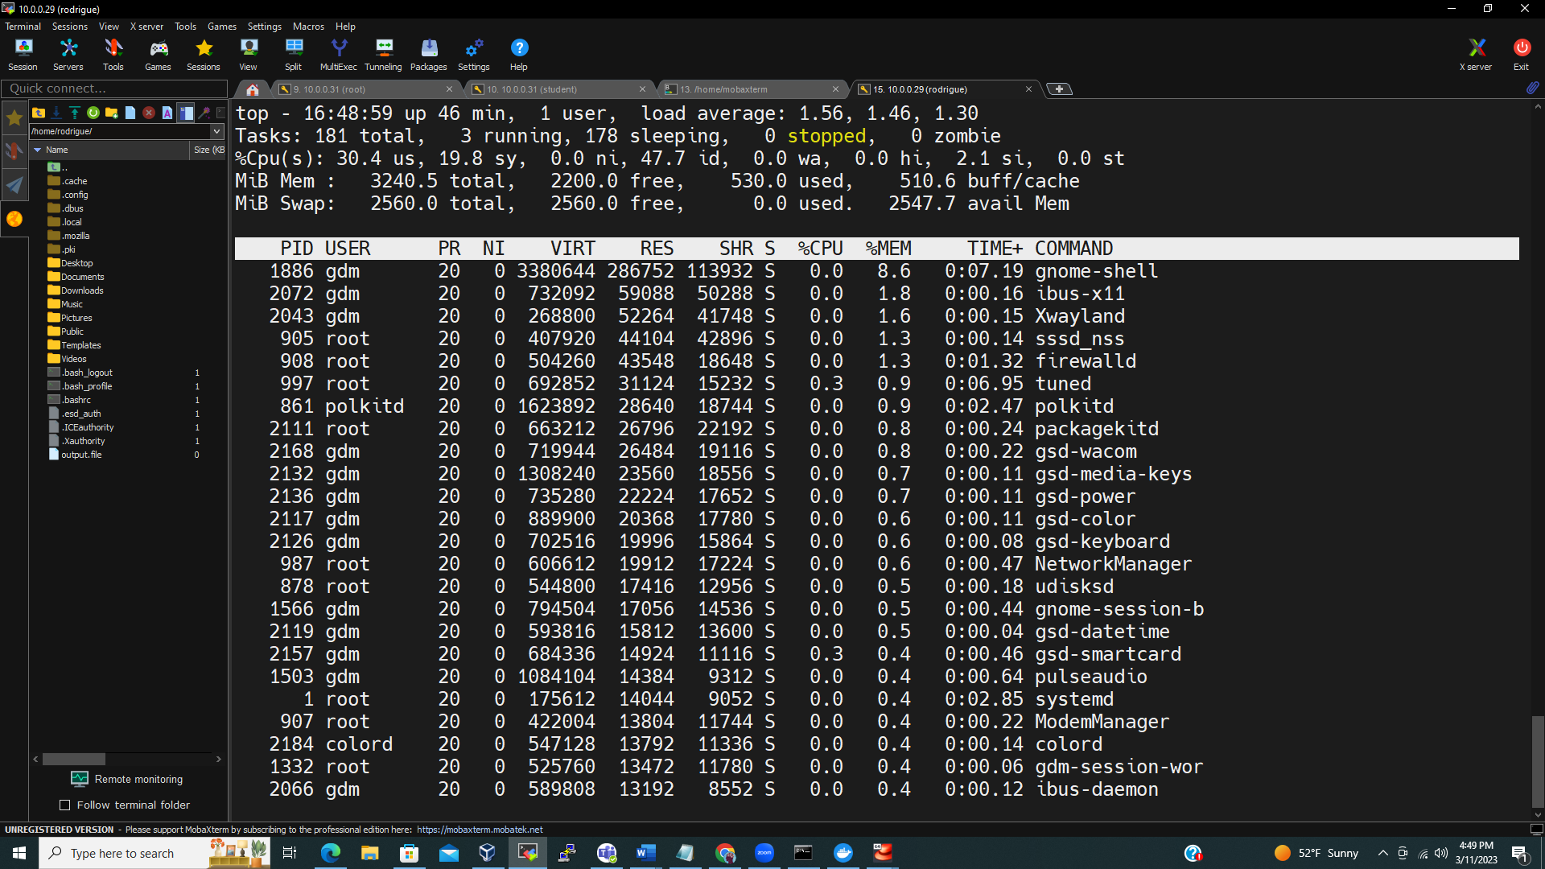

4-

top -o +%CPU or press SHIFT+p or uppercase P

5- PRESS LOWER CASE R ® and enter

6-

After running top command, type k, the interactive mode appear (green color). Enter the process id (orange) and press enter

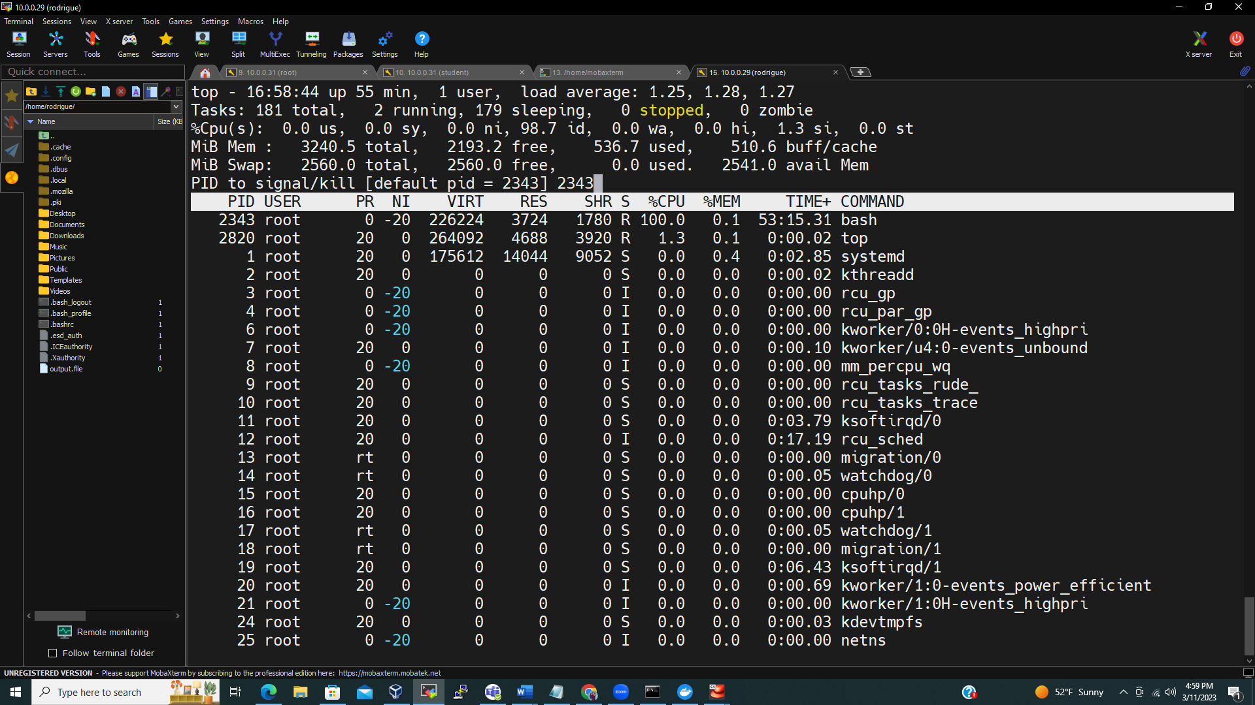

Another interactive mode appears to select the kill option (color green). Enter the kill option using word or number (color orange) and press enter.

